**Software Quality Management System**

Software Quality Management System contains the methods that are used by the authorities to develop products having the desired quality.

Managerial Structure

Quality System is responsible for managing the structure as a whole. Every Organization has a managerial structure.

Individual Responsibilities

Each individual present in the organization must have some responsibilities that should be reviewed by the top management and each individual present in the system must take this seriously.

Quality System Activities

The activities which each quality system must have been:

1. Project Auditing.
2. Review of the quality system.
3. It helps in the development of methods and guidelines.

**Evolution of Quality Management System**

Quality Systems are basically evolved over the past some years. The evolution of a Quality Management System is a four-step process.

1. The main task of [quality control](https://www.geeksforgeeks.org/differences-between-quality-assurance-and-quality-control/) is to detect defective devices, and it also helps in finding the cause that leads to the defect. It also helps in the correction of bugs.
2. [Quality Assurance](https://www.geeksforgeeks.org/software-engineering-software-quality-assurance/)helps an organization in making good quality products. It also helps in improving the quality of the product by passing the products through security checks.
3. [Total Quality Management(TQM)](https://www.geeksforgeeks.org/what-is-total-quality-management-tqm-and-just-in-time-jit-kanban/) checks and assures that all the procedures must be continuously improved regularly through process measurements.

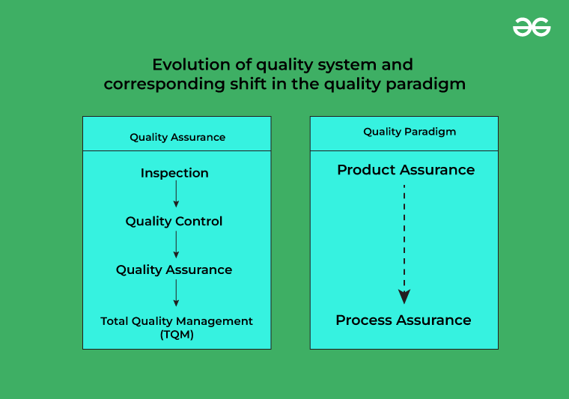



*Evolution of Quality Management System*

By adopting SQM practices, organizations can address common challenges associated with software development, including:

1. Changing Requirements: In dynamic environments, requirements often evolve throughout the development process. SQM helps organizations adapt to changing requirements while maintaining focus on delivering high-quality software products.

2. Complexity: Modern software systems are increasingly complex, involving numerous interdependent components and technologies. SQM provides frameworks and methodologies to manage this complexity effectively, ensuring that software remains robust and reliable.

3. Time-to-Market Pressure: In competitive markets, organizations face pressure to deliver software products quickly without compromising quality. SQM enables organizations to balance speed and quality, facilitating faster time-to-market while minimizing the risk of defects and failures.

4. Customer Expectations: With rising user expectations, delivering software that meets or exceeds customer expectations is paramount. SQM helps organizations understand customer needs, gather feedback, and prioritize features and improvements to enhance customer satisfaction.

Overall, SQM serves as a strategic imperative for organizations seeking to excel in today's digital landscape. By establishing a culture of quality, investing in processes and tools, and continuously improving their software development practices, organizations can achieve higher levels of customer satisfaction, operational efficiency, and competitive advantage.

**Key Principles and Frameworks**

Effective Software Quality Management is built upon a foundation of key principles and frameworks that guide organizations in achieving and maintaining high levels of software quality. These principles provide a roadmap for developing robust processes, establishing standards, and fostering a culture of quality within the organization. Additionally, frameworks offer structured approaches for assessing, measuring, and improving software quality across various dimensions.

One of the most widely recognized frameworks in the field of SQM is the ISO/IEC 25010 standard, which provides a comprehensive model for software quality characteristics. This standard defines eight quality characteristics:

1. Functionality: The degree to which the software meets specified functions and user requirements.

2. Reliability: The ability of the software to perform its functions consistently under various conditions.

3. Usability: The ease of use and user-friendliness of the software interface.

4. Efficiency: The performance efficiency and resource utilization of the software.

5. Maintainability: The ease with which the software can be modified, updated, or repaired.

6. Portability: The ability of the software to be transferred from one environment to another.

7. Compatibility: The interoperability of the software with other systems, platforms, or devices.

8. Security: The ability of the software to protect against unauthorized access, data breaches, and cyber threats.

**Continuous Improvement and Feedback Loops**

Continuous Improvement is a fundamental principle of Software Quality Management, emphasizing the iterative nature of software development and the importance of ongoing refinement and enhancement. By establishing feedback loops and embracing a culture of continuous learning and improvement, organizations can identify opportunities for optimization, address issues, and drive innovation throughout the development lifecycle.

Agile methodologies, such as Scrum and Kanban, embody the principles of continuous improvement by promoting collaboration, transparency, and adaptability within development teams. Through regular retrospectives and feedback sessions, Agile teams reflect on their performance, identify areas for improvement, and commit to making incremental changes to enhance their processes and practices.

One of the key benefits of continuous improvement is its ability to foster innovation and creativity within development teams. By empowering team members to experiment, take risks, and learn from failures, organizations can drive innovation and discover new approaches to solving complex problems.

**Tools and Technologies for SQM**

Effective Software Quality Management relies on a variety of tools and technologies to support and streamline quality assurance processes, testing activities, and overall quality management practices. These tools provide organizations with the means to automate repetitive tasks, improve collaboration, and gain insights into the quality and performance of their software products.

One of the most essential tools for SQM is a Test Management System (TMS), which enables organizations to plan, execute, and track testing activities efficiently. TMS platforms provide features such as test case management, test execution tracking, defect tracking, and reporting, allowing QA teams to manage testing efforts effectively and ensure comprehensive test coverage.

Test Automation Frameworks are another critical component of SQM, enabling organizations to automate the execution of test cases and scenarios across different platforms, browsers, and devices. Popular test automation frameworks include Selenium, Appium, and Robot Framework, which provide robust libraries and tools for automating web, mobile, and desktop application testing.

Version Control Systems (VCS) play a crucial role in SQM by enabling developers to manage changes to source code, track revisions, and collaborate on software projects effectively. Git is one of the most widely used VCS platforms, providing features such as branching, merging, and distributed version control, which streamline collaboration and facilitate code review and integration.

Integrated Development Environments (IDEs) are essential tools for developers, providing a unified interface for writing, debugging, and testing code. IDEs such as Visual Studio Code, JetBrains IntelliJ IDEA, and Eclipse offer features such as syntax highlighting, code completion, and built-in debugging tools, which enhance developer productivity and code quality.

Continuous Integration (CI) and Continuous Deployment (CD) tools automate the process of building, testing, and deploying software, enabling organizations to release updates quickly and reliably. Popular CI/CD platforms include Jenkins, Travis CI, and CircleCI, which integrate with version control systems and testing frameworks to automate the software delivery pipeline.

In addition to these tools, organizations can leverage various quality metrics and monitoring tools to assess the performance and reliability of their software products in real-time. These tools provide insights into key quality indicators such as code coverage, defect density, and mean time to failure, enabling organizations to identify areas for improvement and make data-driven decisions.

Overall, tools and technologies play a critical role in supporting and enhancing Software Quality Management practices, enabling organizations to automate repetitive tasks, improve collaboration, and gain insights into the quality and performance of their software products. By leveraging these tools effectively, organizations can streamline their SQM workflows, accelerate delivery cycles, and maintain high standards of software quality.

**Conclusion:**

In conclusion, effective Software Quality Management is essential for organizations seeking to deliver high-quality software products that meet customer expectations, adhere to standards, and perform reliably in diverse environments. By adopting robust SQM practices, organizations can mitigate risks, reduce costs, and enhance customer satisfaction, ultimately driving business success in today's competitive marketplace.